# Testing

## Main Page

Main page without login



## Sign up Page

Create a new user with admin profile

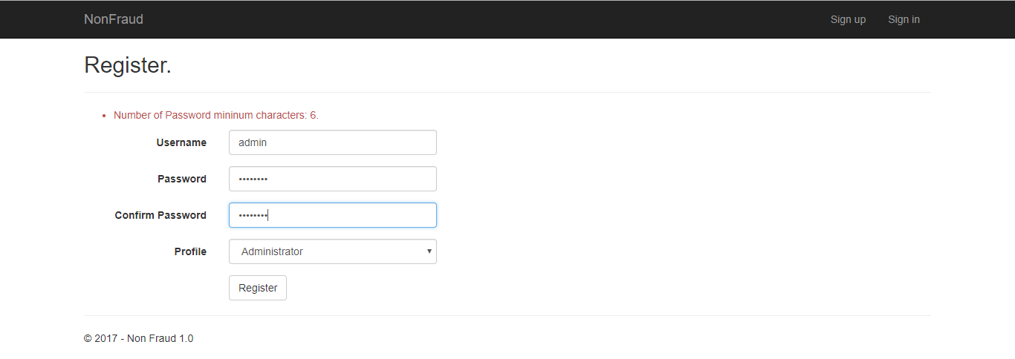

As we can see, the new user is Administrator and has permissions in the three menu options

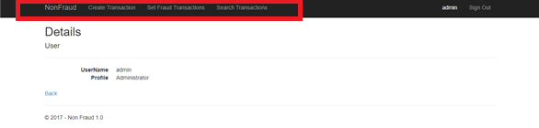

## Login Page

Enter with the previous created user

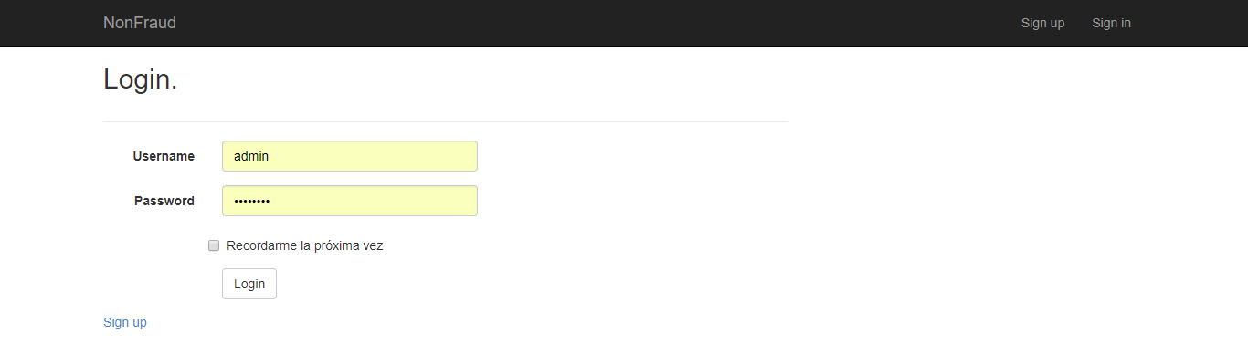

## Set Fraud Transaction

In this screen we can see the list of transactions and set as fraud.

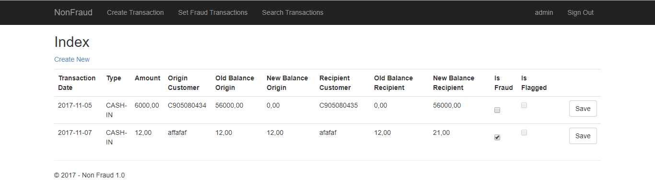

## Search Transactions

Search transactions according to the required

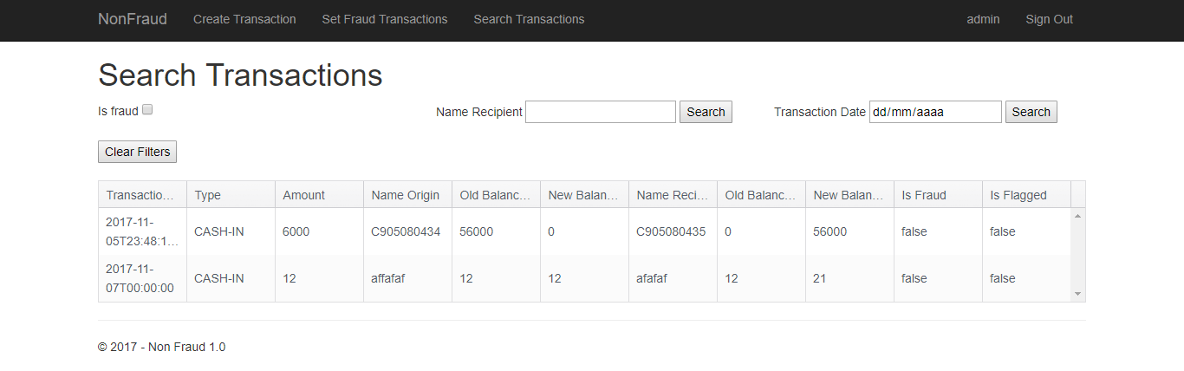

Search by date for example

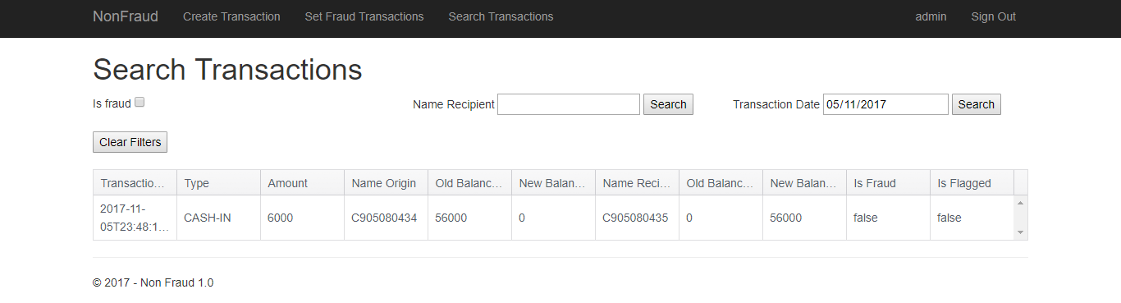

## Profile Permissions

Assist profile

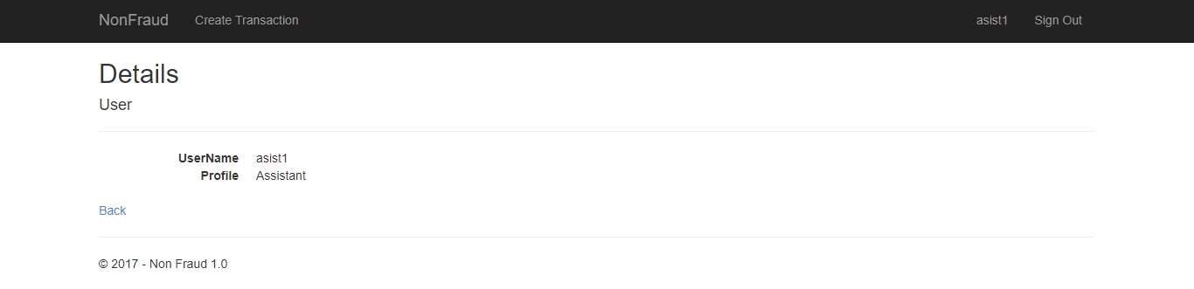

Manager profile

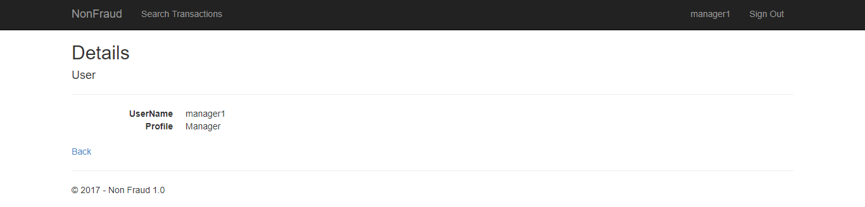

Superintendent profile

